MOOC 4-MODULE 4
Unsupervised Machine Learning

I.Dimensionality Reduction: Overview
Overview of Dimensionality Reduction
- Dimensionality reduction addresses the curse of dimensionality by creating lower-dimensional representations of data.
- It helps improve model performance by reducing the number of features, which can lead to better distance measures and fewer outliers.
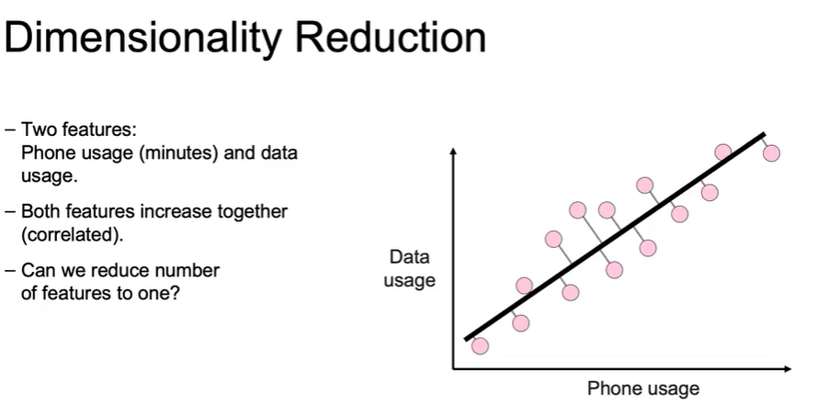
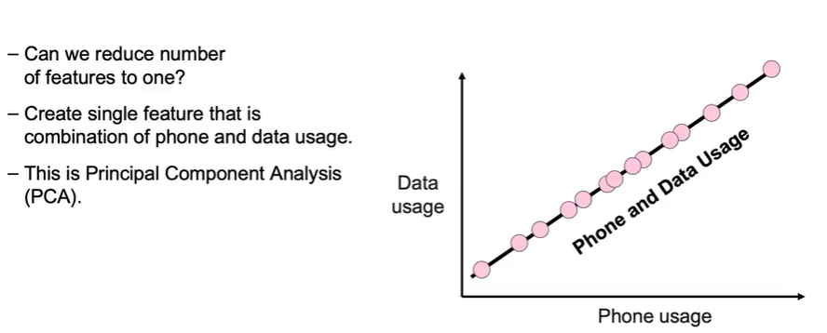
Principal Component Analysis (PCA)
- PCA is a technique used to generate new features in a lower-dimensional space by combining existing features.
- It involves linear transformations that project data points onto a line, effectively reducing dimensions while maintaining variance.
Non-Negative Matrix Factorization
- This method decomposes original data into positive values, further reducing dimensions.
- It is particularly useful for datasets where negative values are not meaningful, allowing for a more interpretable representation.

II.Dimensionality Reduction: Principal Component Analysis
Understanding PCA
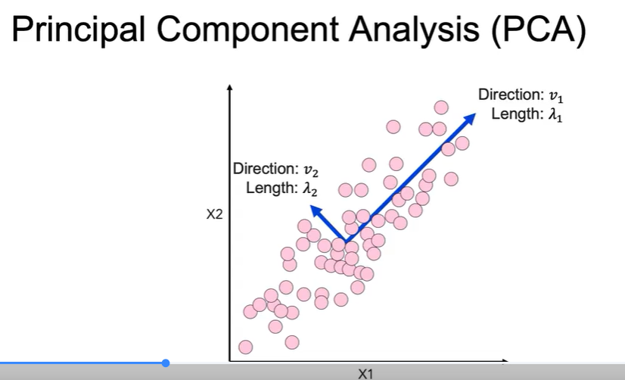
- PCA reduces the dimensionality of datasets by projecting data onto principal components, which are the directions of maximum variance.
- The primary right singular vector represents the direction with the most variance, while the secondary right singular vector is orthogonal to it.
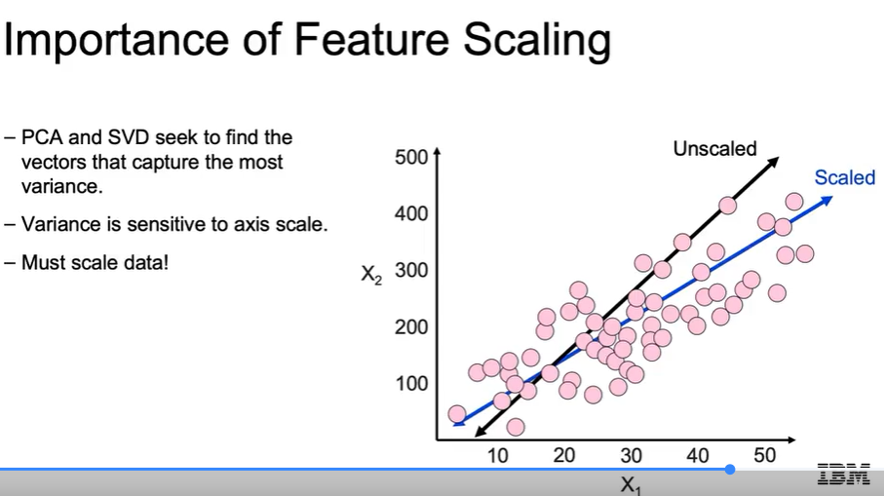
Mathematical Foundations
- PCA uses SVD to decompose a dataset matrix into three matrices: U, S, and V, where S contains the lengths of the principal components.
- The diagonal entries of S are sorted from largest to smallest, indicating the importance of each principal component.
Implementation in Python
- To perform PCA using Scikit-learn, you create an instance of the PCA class, specify the number of components, and use the fit_transform method to reduce the dataset's dimensions.
- Proper scaling of data is crucial before applying PCA to ensure accurate projections and maintain variance.
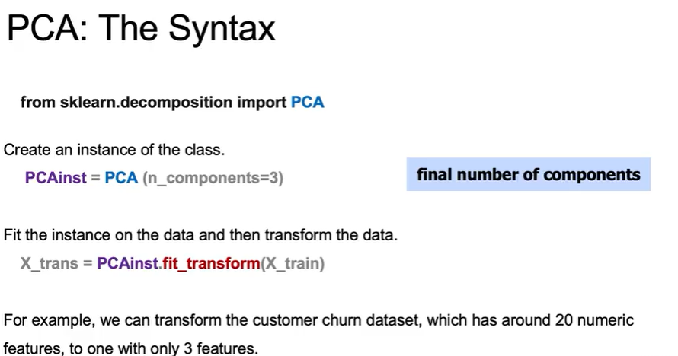

III.Dimensionality Reduction Imaging Example
Dimensionality Reduction in Practice
- PCA is used to compress an image by reducing the number of features while retaining most of the original information.
- High-dimensional data, such as images, can have many features, like pixel brightness values, which PCA helps to simplify.
Image Representation and PCA Application
- The image is divided into 12x12 pixel squares, each representing a single observation with 144 pixels.
- PCA is applied to create a new matrix with fewer dimensions, allowing for a compressed representation of the image.
Results of Dimensionality Reduction
- The lecture demonstrates reducing dimensions from 144 to 60, then to 16, and finally to 4, showing that the image remains recognizable at each stage.
- The L2 error is analyzed to assess the difference between the original and compressed images, indicating that significant information is retained even with reduced dimensions.

